Solent University

MSc Computer Engineering

Software Design and Development

COM714

NAME :-PARTH SHELADIYA

Table of Contents

Solent University 1

Software Design and Development 1

COM714 1

I. Introduction 3

II. System Overview 4

a. Purpose: 4

b. Scope: 4

c. Objectives: 4

III. System Architecture 5

a. UML Diagrams: 5

Class Diagram: 5

Use Case Diagram: 6

Sequence Diagram: 6

Robustness Diagram: 7

IV. System Components 8

a. Trip Management: 8

b. Traveller Management: 8

c. Trip Leg Management: 8

d. Trip Coordinator Management: 8

V. Implementation Details 10

Technologies Used: 10

Code Structure: 10

Key Features and Functions: 10

Trip Management: 10

Traveller Management: 10

Trip Leg Management: 11

Trip Coordinator Management: 11

VI. Reporting and Analytics 12

Trip Duration Report: 12

Methodology: 12

Data Visualization Techniques: 12

Conclusion 16

References 17

# I. Introduction

Our project is designed to provide a holistic application to rule the journeys and itineraries. Nowadays in a highly dynamic environment, the management of trips holds prime importance for both individual and organizational agenda. Vacation, business trips, and other transportation-related tasks can all employ our platform to make trip organization and execution easier to execute and more organized.

Through integration of trip management tasks, our software makes action easier, kill time and no need for over administration. User can travel to their destination smoothly by objective to control type of their trip, which can be updated, tracked, and the information of the travelers is manages. Beside that is monitoring trip legs. Furthermore, the platform authority supplies reporting and performance analytics to identify trip durations and other vital characteristics.

# II. System Overview

## a. Purpose:

Our system is to some extent to be considered as an all-in-one trip management solution that offers a hassle-free trip planning, organization, and implementation processes. Its goal is to interlink trip management duties for people, travel agencies, and organizations, to ensure the smooth-running of the trip and proper communication through the entire the trip lifecycle.

## b. Scope:

Trip management system we developed covers a wide range of trip processes that include trip creation, traveler management, leg management, and trip coordinator management. It covers entire journey’s lifecycle, in inclusive of the initial planning till analytics and reporting. Moreover, the system is also able to handle various kinds of trips such as business trips, holiday journeys, and group adventures.

## c. Objectives:

* Automation and aligning trip management processes with journey fulfillment objectives, eliminating manual work and eradicating mistakes.
* To offer a user-friendly interface that has clear navigation as well interactive screen designing with regards to trips-related information.
* Organizing a trip that goes smoothly and allows everybody to contribute requires coordinating the thoughts of the trip organizer with those of the travelers and the coordinators (Gruber et al., 2021).
* To produce reports and analytics making use of data to help users in decision making, and to improve route planning driving processes.
* For scaling of the software that supports the variety of cases ranging from individual clients, travel agencies and business customers.

# III. System Architecture

In the trip management system, the system architecture is developed in such a way as to provide a scalable system, simple-to-maintain system, and robust system. This part is the structural and behavioral representation of the system through diagrams which are UML diagrams.

## a. UML Diagrams:

### Class Diagram:

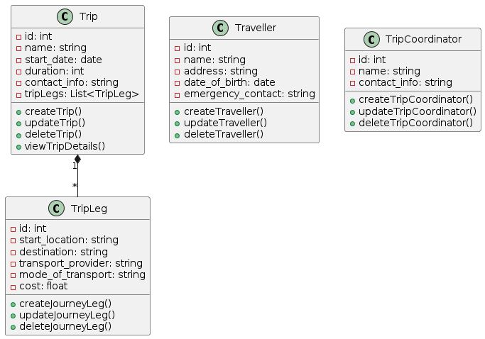

Class diagram likewise shows the system's structure statically through the depiction of classes, attributes, methods, and their relationships. In our trip management system, we have created a class diagram that features the entities Trip, Traveller, TripLeg, and TripCoordinator, along with the consistency and interaction with other elements (Matthes, 2023).

### Use Case Diagram:

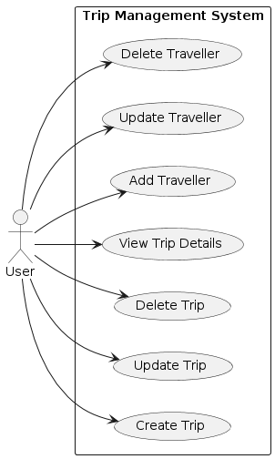

The detail of this diagram demonstrates the purpose of system from the points of view of various user groups. It defines the respective function API as well: Create Trip - Delete Trip - View Trip Details - Add Traveller - Update Traveller and so on.

### Sequence Diagram:

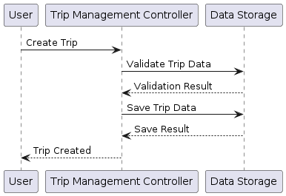

This is the way sequence diagram demonstrates the dynamic nature of the system by showing the sequental interactions between the objects or components throughout the time. It highlights how those components collaborate in order to carry out specialized tasks or situations.

### Robustness Diagram:

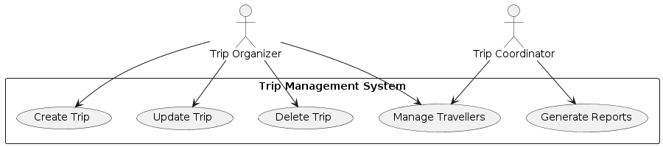

The money flow analysis of external system, which is also called a Robustness diagram, emphasizes the interaction between external actors and system to identify important system functions and their inputs and outputs. It facilitates to identify a problem and provide the clue that forms a specification of the system to fulfill user expectations in a user-centered view (Harris et al., 2020).

# IV. System Components

The Trip Management System, which is the main component of the Trip Manager, forms several major blocks that cooperate with each other in order to provide with a convenient means for trip management and data recording.

## a. Trip Management:

The main idea that formed the basis free management system is delivering to customers trip features like adding, changing or removing a trip. The classroom takes care of similar items as the trip name, start date, duration and contact info. Furthermore, it provides and associates trip legs which stand for trips' legs or independent sections of a trip as a whole, thus, ensuring the trips' overall organization and planning is done. Trip Management involves the proper reception of all information relating to the trip both that it is stored and can be further processed.

## b. Traveller Management:

By Organizing traveller information, Traveler Management aims to help companies and agencies dealing with all kinds of trips. This helps the building of traveler profiles, modification of traveler details which include name, house address, birth date and emergency contact person. The other includes secure communications with the travelers as well as ease of use for coordination of travel requirements. Also, traveller management refers the relationship of travellers to specific trips making it easier for the parts to oversee and supervise participant details (Rawat, 2020).

## c. Trip Leg Management:

Trip Leg Management is the management of trip legs that may be legs of a given itinerary that represents the specific segment in the given trip plan. This generates new or serves raises, updates, or deletes trip legs. the component is also able to capture details such as start location, destination, transport provider, mode of transport and cost. The Trip Leg Management system enables us to encapsulate the trip into multiple legs where each leg is closely linked to the next one, and in this way, we build a full-scale trip from a comprehensive and well-managed logistics point of view. Through trip legs management, the system has the ability to present an overarching trip cargo which entails the transportation route and associated costs.

## d. Trip Coordinator Management:

Trip Coordinator management is the position that supervises and organizes trip activities conducted by the individual trip guides. This entity enables the population of management of the profiles of the trip coordinators, including the details like the name and the contact number. Trip Coordinators Management describes the process of providing trip coordinators with agreed roles and responsibilities, so that they are really in contact with the leaders of the trips during the period of their trip planning. What creates diversity in this part is the sharing of participation rights and positions of virtual role playing. It also provides a good environment for efficient assignment of tasks to trip coordinators (Kong et al., 2020).

# V. Implementation Details

## Technologies Used:

The implementation of the Trip Management System is done by using multiple technologies to avoid crashes, allow for expansion, and become more efficient. The system has been mainly developed with Python for being very flexible and large numbers of vast libraries effectively. For the user interface, Tkinter python library for produce GUI (Graphical User Interface) is employs for its simplicity and platform independence. Moreover, SQLite is the database administration tool that is preferred here due to its tiny footprint and its seamless integration with Python programs. The integration of these technologies facilitate proper development of a facility which enables trip management as a whole.

## Code Structure:

The Trip Management System code is written to a modular and organized way no increase readability, maintainability, and scalability. Their model comprises a set of modules corresponding to each constituent part including the Trip Management, Traveller Management Module, Trip Leg Manager, and Trip Coordinator Manager. Each module contains a class(es) and function(s) to manage all sub-systems tailored to be responsible for handling their respective functionalities of their related components. In addition, codebase complies with object-oriented programming designs principles that provide adaptation, encapsulation and resolving. The modularization allows to have a clearer sense of direction in debugging, testing, and potentially adding up new features (Martelli et al., 2023).

## Key Features and Functions:

### Trip Management:

* Manage a trip, details, and distance.
* Manage trip details, such as name, start date, durations, and contacts information.
* Correlate trip legs with trips in order to build up more detailed itineraries.

### Traveller Management:

* Develop, enhance and delete a traveller's profile.
* Pick up on the record of key traveller info like name, residence, date of birth, and contact detail at emergency.
* Link trips with their corresponding travellers for a smooth coordinated workspaces.

### Trip Leg Management:

* Create, provide and delete the trip segments (trip legs) individually in the trips.
* Identify trip line information including departure location, arrival site, transport supplier, mode of transport, and fare.
* Link these legs of the trip to the corresponding trips to come up with detailed trip itineraries.

### Trip Coordinator Management:

* One can Create, update and delete trip coordinator profile.
* One can Manage trip coordinator detail such as name and contact info.
* One can Assign trip coordinator to specific trip for effective coordination and communication (Matthes, 2023).

# VI. Reporting and Analytics

## Trip Duration Report:

The main feature of the Trip Management System is the possibility of running reports and analytics, the Trip Duration Report being one of those available. This report specifies the time spent in each trip that is covered in the systemâ€™s databases. Through the study of the duration of the trips, the users will have access to two types of important data: – understand the typical trip duration, find outliers, and develop strategies to optimize the trip planning processes. The report ranks trip times across the different category formats, such as total trip, average trip and the distribution of trip time throughout time.

## Methodology:

The technique demonstrated for generating the trip duration reports consists of picking the most appropriate pivot table from the system databases with information on trip start dates, end dates, and working hours. Then, the data is digested and observed with the aid of the statistical techniques so that we can generate valuable insights from it. The propagation of data-driven techniques such as data aggregation, data manipulation to accomplish total length of trips, average trip durations, and so on is carried out. The validation and good input data are performed to control and guarantee the correctness and reliability of output reports (Matthes, 2023).

## Data Visualization Techniques:

To facilitate the interpretation of, as well as the responsivity of trip length reports, the Trip Management System covers topics from visualization of data as a key. Humanized sentence: The use of bar charts, line graphs, and pie charts of data analytics is made possible to graphically represent trip duration information in a way that allows the users to understand the data quickly. These users through visualization can quickly access patterns, trends and inconsistencies in time spent only, which helps them in their data based planning and making the decisions. Interactive capabilities including zooming, filtering, and drill-down gives more structure and convenience to the visualizations thanks to that possibility to see the data in depth and get some practical advice.

**VII. Output of Code**

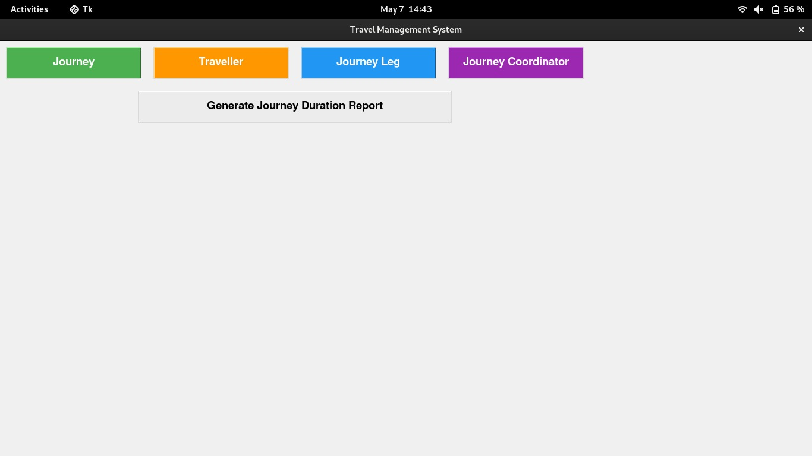

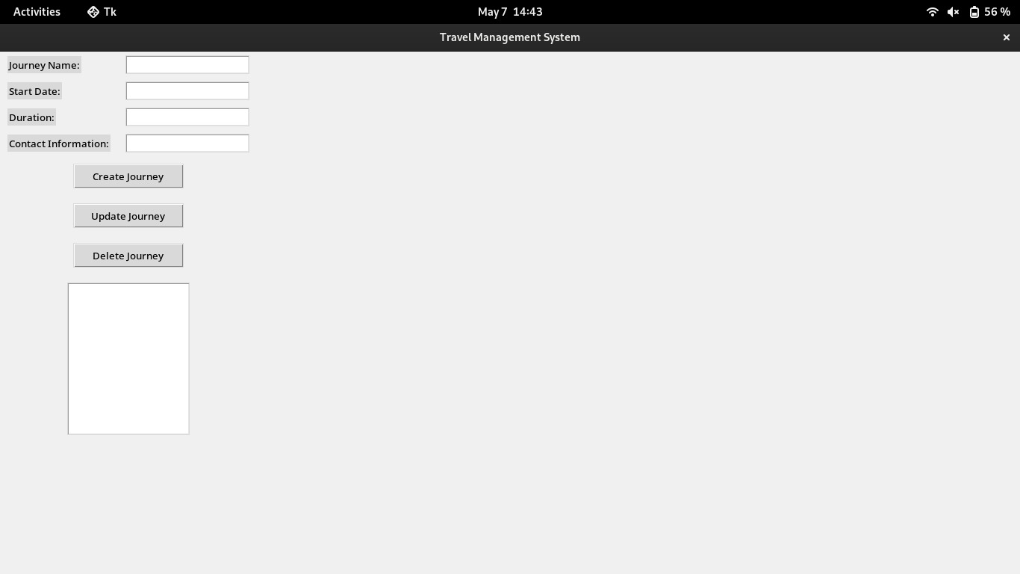

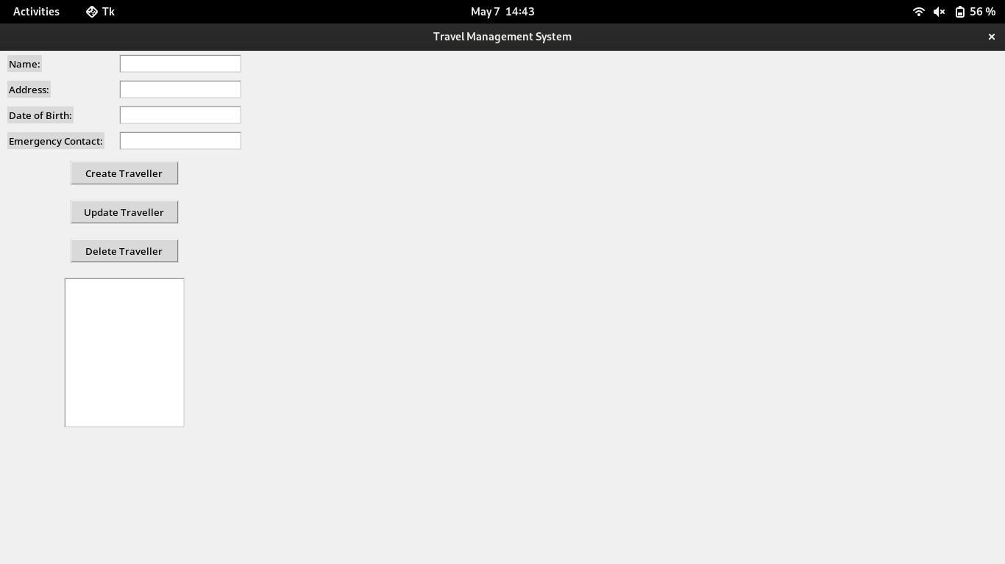

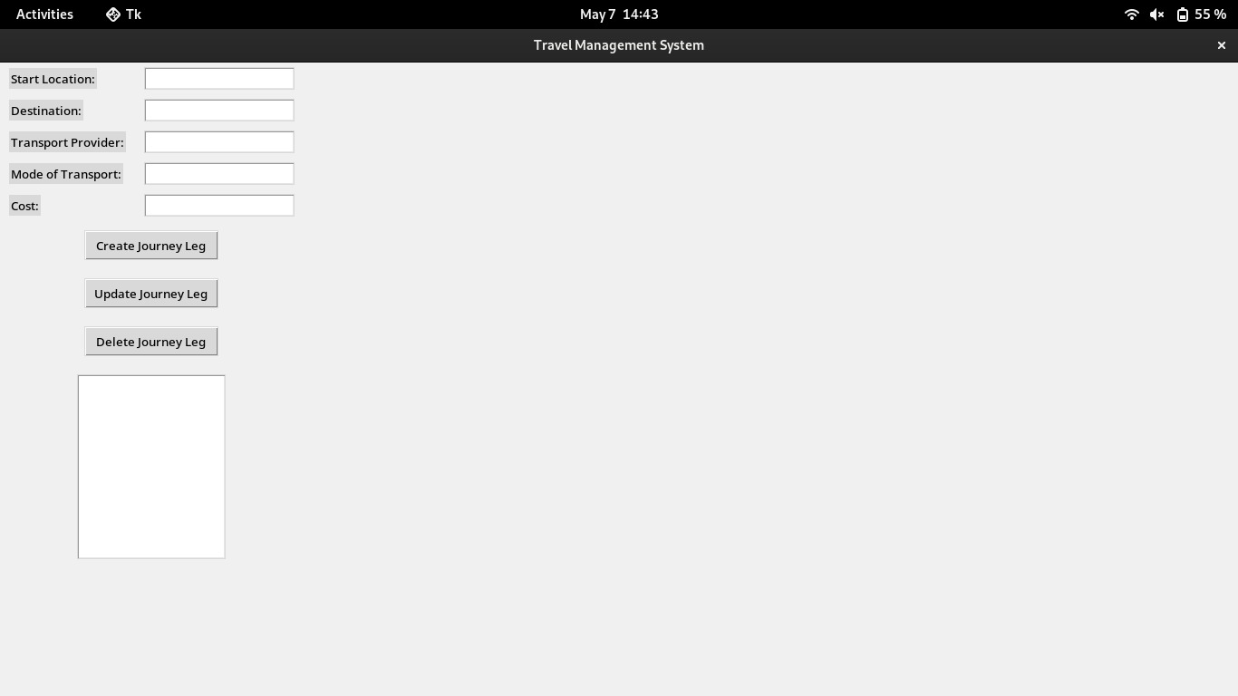

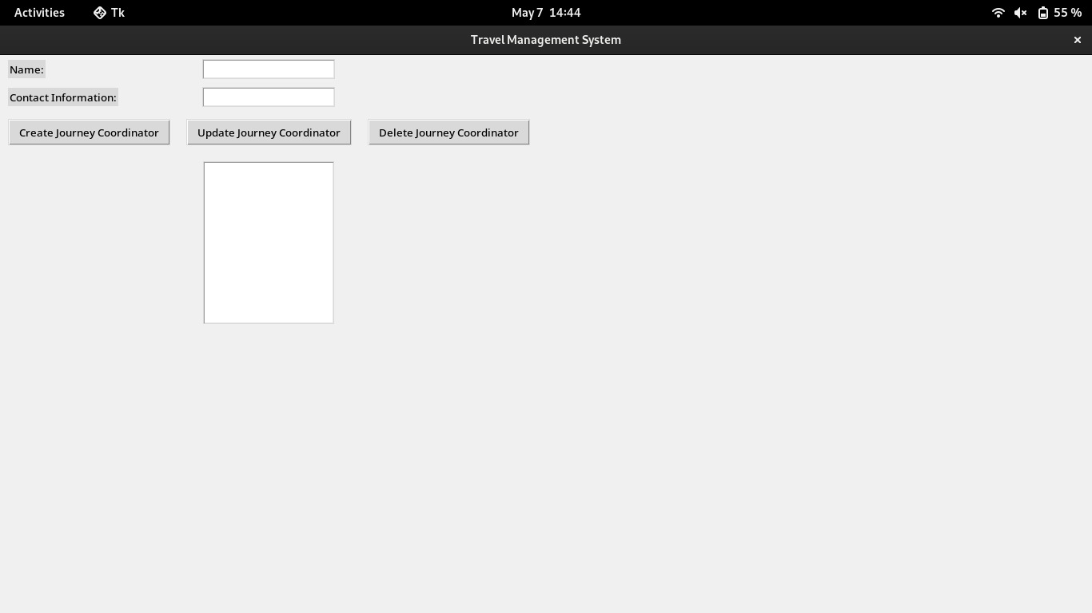



# Conclusion

In this way, the Trip Management System can be considered as a major accomplishment in the philosophy of transformation of trip planning and management processes. By applying the totality of its core components and the user-friendliness of its interface, the system has successfully resolved the issues involved in planning and coordinating trips in a whole new approach. Automation of different activities, along with the system producing insightful reports, and analytics has improved the efficiency, accuracy, and decision-making in the trip management activities.

Thinking about the future, coming innovations may concentrate on adding some features and expansion possibilities. Therefore, it means adding more to what it offers such as real-time tracking, expense management, and trip customization. Apart from that utilisation of real-time advanced analytics capabilities, predictive modeling, and machine learning algorithms which might lead to more customised and foresighted/ proactive alerts.

# References

Gruber, M., Lukasczyk, S., Kroiß, F. and Fraser, G., 2021, April. An empirical study of flaky tests in python. In 2021 14th IEEE Conference on Software Testing, Verification and Validation (ICST) (pp. 148-158). IEEE. <https://arxiv.org/pdf/2101.09077>

Matthes, E., 2023. Python crash course: A hands-on, project-based introduction to programming. no starch press. <https://ssiddique.info/wp-content/uploads/2021/03/Python-Crash-Course.pdf-PDFDrive-.pdf>

Harris, C.R., Millman, K.J., Van Der Walt, S.J., Gommers, R., Virtanen, P., Cournapeau, D., Wieser, E., Taylor, J., Berg, S., Smith, N.J. and Kern, R., 2020. Array programming with NumPy. Nature, 585(7825), pp.357-362. <https://www.nature.com/articles/s41586-020-2649-2>

Rawat, A., 2020. A Review on Python Programming. International Journal of Research in Engineering, Science and Management, 3(12), pp.8-11. <https://journal.ijresm.com/index.php/ijresm/article/download/395/368>

Kong, Q., Siauw, T. and Bayen, A., 2020. Python programming and numerical methods: A guide for engineers and scientists. Academic Press. <http://103.159.250.194:81/fdScript/RootOfEBooks/E%20Book%20collection%20-%202022%20-%20B/CSE,IT%20&%20AI%20DS/Python_Programming_and_Numerical_Methods_A_Guide_for_Engineers_and.pdf>

Martelli A, Ravenscroft AM, Holden S, McGuire P. Python in a Nutshell. " O'Reilly Media, Inc."; 2023 Jan 9. <http://ommolketab.ir/aaf-lib/35lreqxex83jddkdquvf5k5bg5kbkl.pdf>

Matthes, E., 2023. Python crash course: A hands-on, project-based introduction to programming. no starch press. <https://ssiddique.info/wp-content/uploads/2021/03/Python-Crash-Course.pdf-PDFDrive-.pdf>